**Micro Services**

* Small autonomous services that work together.
* Micro service is an architectural style is an approach to developing a single application as a suite of small services. Each running on its own process and communicating with light weight mechanisms like HTTP resource API.
* These are independently deployable, and all these services have a centralized management. These services can may be written using different programming languages and different data storage technologies.
* Micro services are services that are exposed by REST with small deployable units and cloud enabled (able to bring up a service or bring down one without having huge problems).

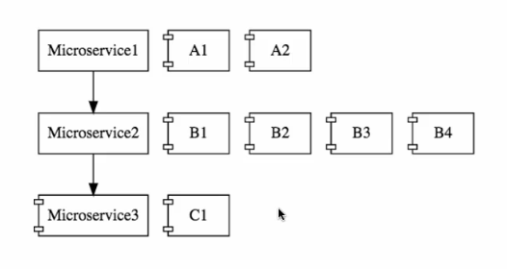

**Challenges**:

* Bounded Context:
  + Difficult to set boundaries, need to have more experience to do that.
* Configuration management:
  + If each instance has different configuration, then it is tons of configuration.
* Dynamic Scale up and down:
  + Can be able to bring up instances of micro services up and down and dynamically distribute load between them.
* Visibility:
  + Need to have a centralized log what happened to a specific request. Also need to be monitoring these services automatically.
* Pack of Cards:
  + These micro services are built like pack of cards one on other. If one service goes down all the rest will go down. So, our micro services need to have fault tolerance.

**Spring Cloud: (Finchely M2 release)**

* Spring cloud provides tools for developers to quickly build some of the common patterns in distributed systems.

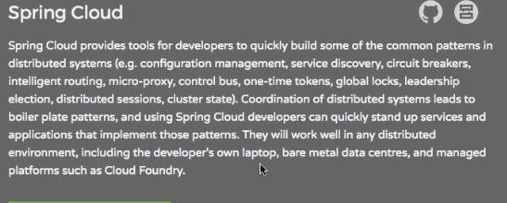

* There are many projects in spring cloud like
  + **Spring cloud config**: centralized external configuration management backed up in a git repository.
  + **Spring cloud Netflix**: Integration with various Netflix OSS components like Eureka, hystrix and Zuul.
  + **Spring cloud bus**: An event bus for linking services together with distributes messaging (config server and API gate way talk to each other).

**Spring Cloud Config Server: (solves Configuration management)**

* Provides an approach where we can store all configuration for all different environments of all the micro services in a Git repository.

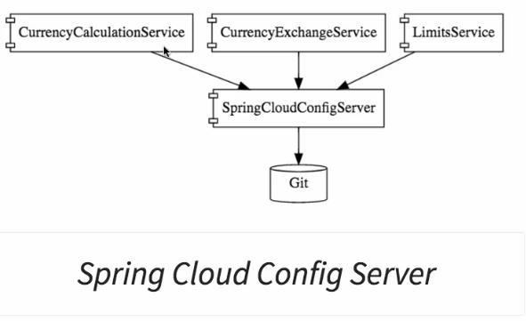

* Helps to keep the configuration in one place and very easy to maintain.

**Solutions:**

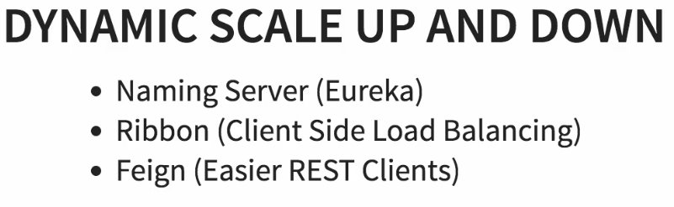

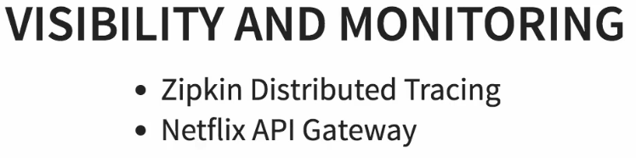

* In order to implement common features like logging, security, analytics API gateway give solutions for all these.

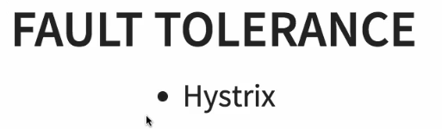

**Advantages:**

* **Faster release cycles:** New features faster to the market.
* Dynamically increase instances during rush seasons.
* Adaption of new technologies and processes.

**Spring cloud Configuration:**

* Each micro service will have different number of environments with different number of instances.

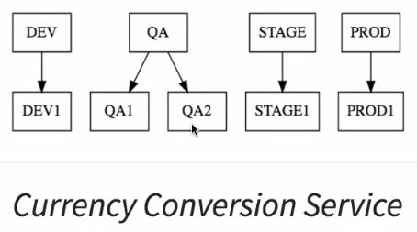

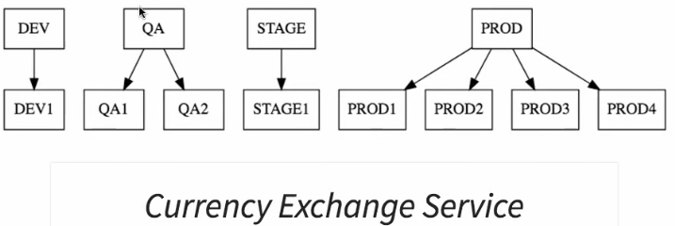

**Multiple micro services 🡺 multiple environments 🡺 multiple instances**

* So, managing the configuration for each application each environment is very difficult. This is where centralized configuration comes in to picture using spring cloud.
* We need to put all these configurations for different environments in git repository and can connect spring cloud config server to the git repository. It can serve the configuration based on needs of different instances and environments.
* Git config repo has properties files for different environments.

**Limits service:**

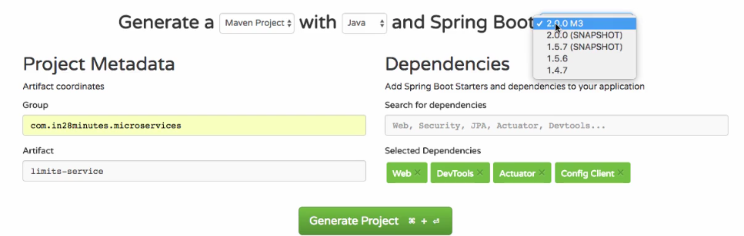

* we can get the values from application.properties file by using @Value annotation. Here spring boot provides a better approach by creating configuration class.

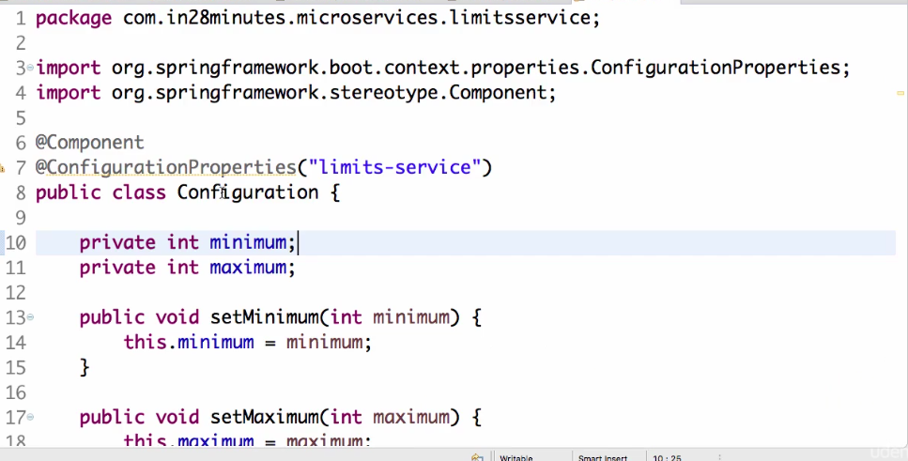

and you can autowire it like below

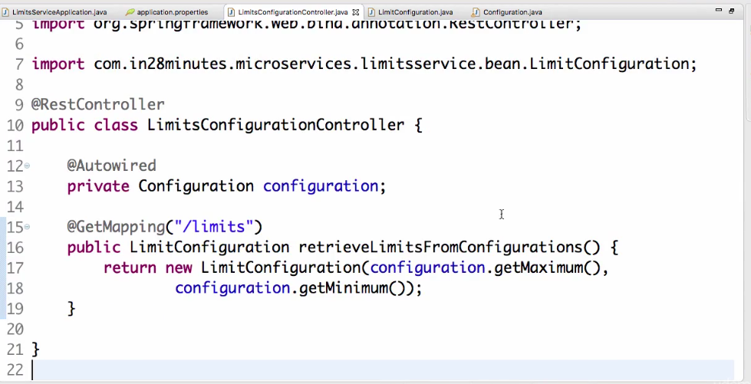

* we need connect limits server to spring cloud config server.

**Spring Cloud Config server:** manages configuration of multiple micro services for diff env.

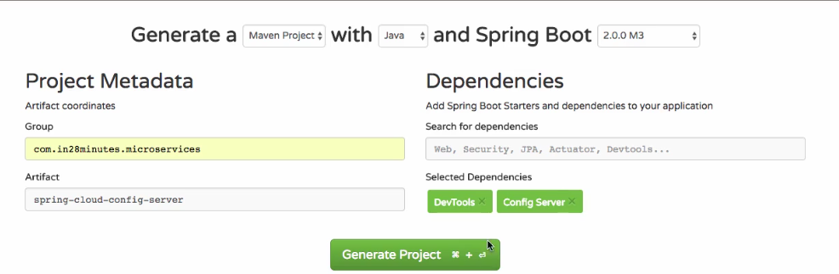

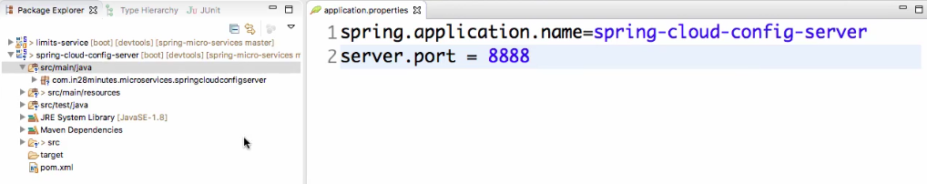

* Now need to create Git repo and connect it to spring cloud config.
* Add link to git config folder using Link source in eclipse.

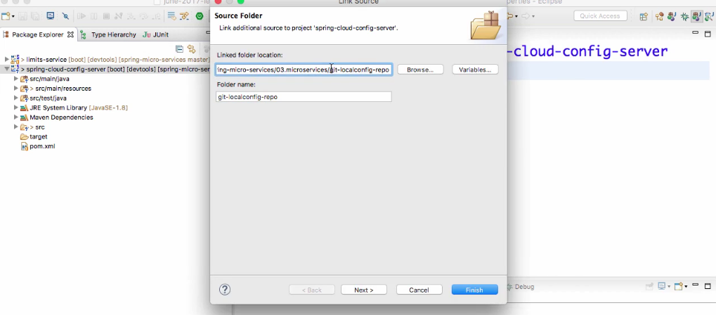

* In git repo create configuration files for different environments.

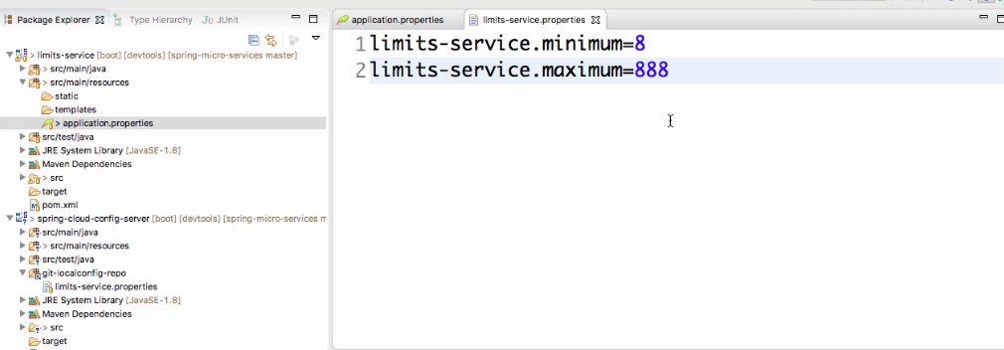

* Now need to connect Spring cloud config server to local git repository. By adding repo uri in config server application properties file.
* **Also need to enable spring cloud config server using @EnableConfigServer**

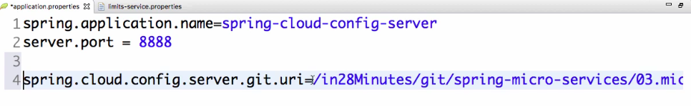

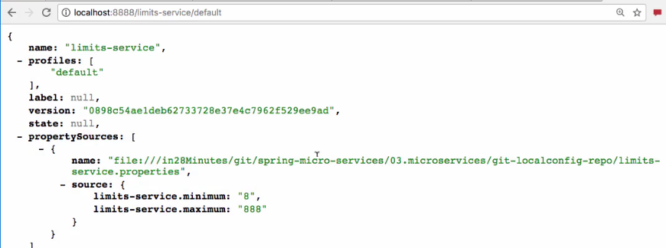

So, in the git repo we can store configuration for multiple environments for a micro service.

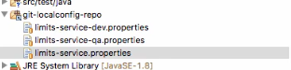

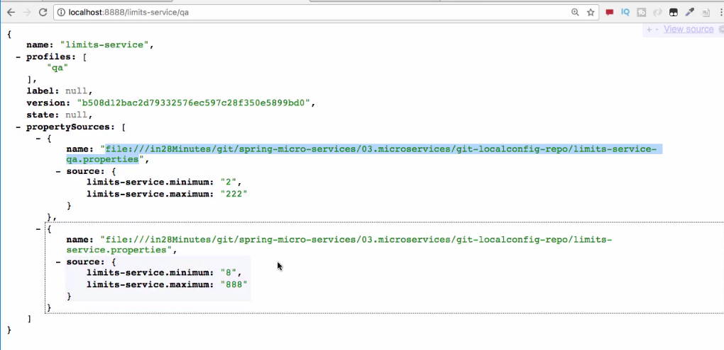

* Now it’s time to connect limit service to Config server to pick up values from git repo. For this the properties file need to rename to bootstrap.properties and mention URI of spring cloud config server.

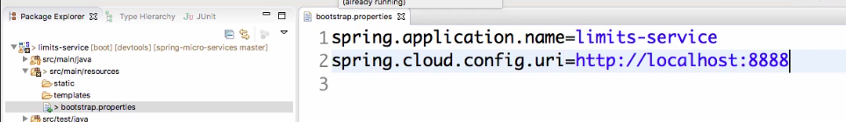

* Based on application name it pick ups values from spring cloud config server. By default it uses default configuration.
* 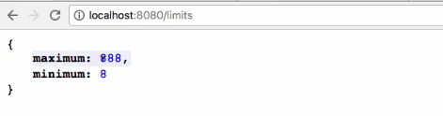
* We can configure to pickup different profiles for Dev and QA. By this we need not worry before deploying about configuration, because spring cloud config takes care about that.

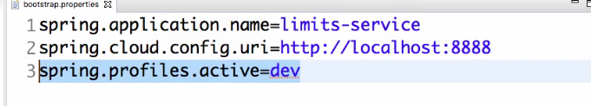

* We can also configure using VM arguments or Java application arguments. Now it picks up values of Dev file.
* Need to restart config server and limits for every change.

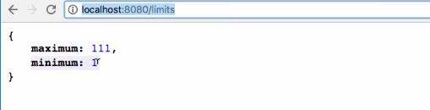

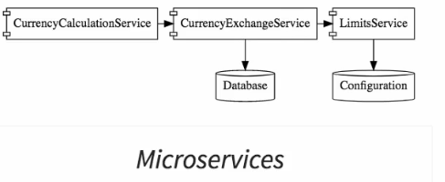

**Setting Currency Exchange service:**

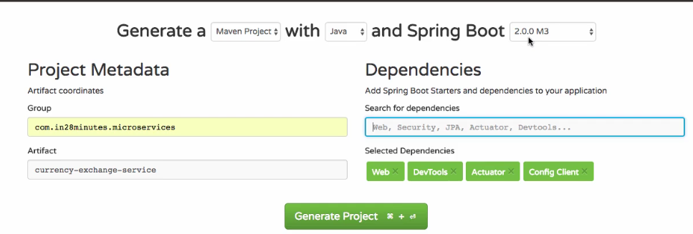

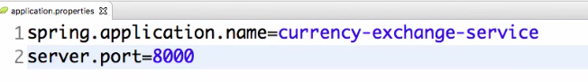

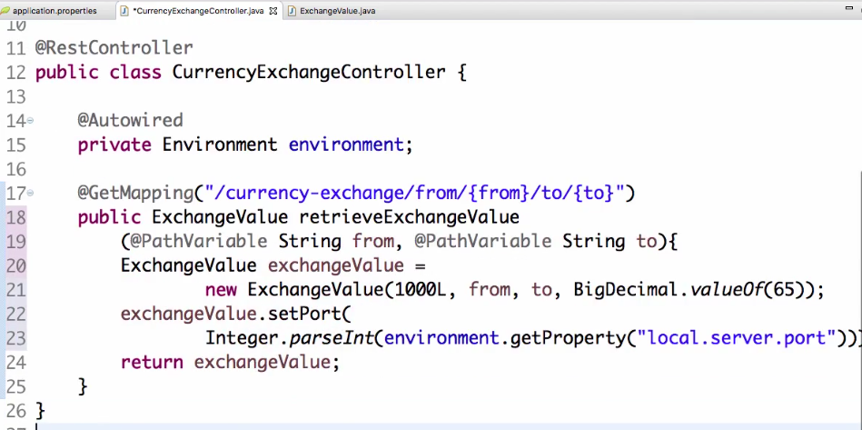

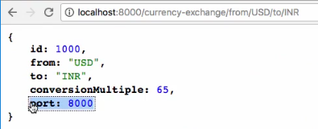

To launch other instance in eclipse 🡺 go to Run configurations 🡺 duplicate and pass Vm arguments.

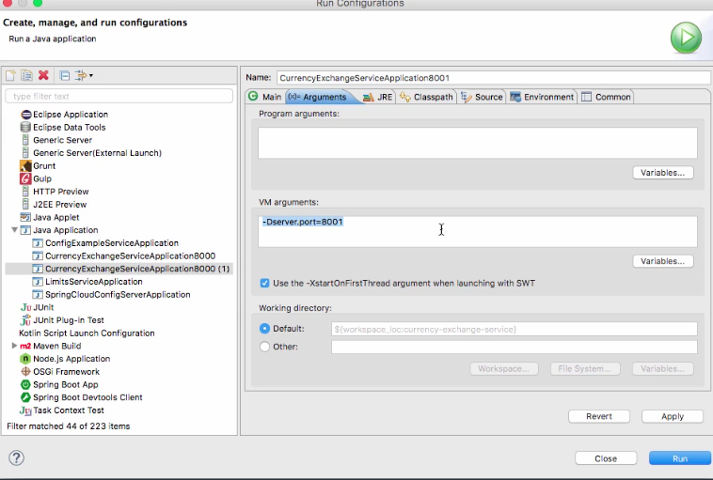

Now there are two instances of service running on 8000 and 8001.

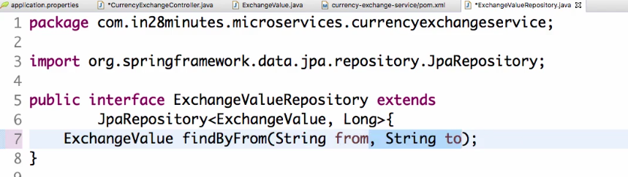

Then update controller class

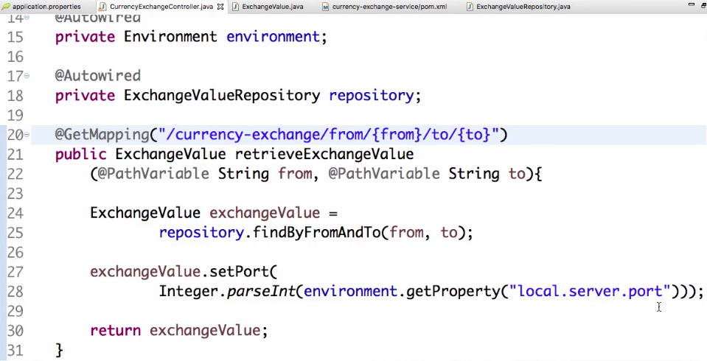

**Setting Up Currency Conversion Service:**

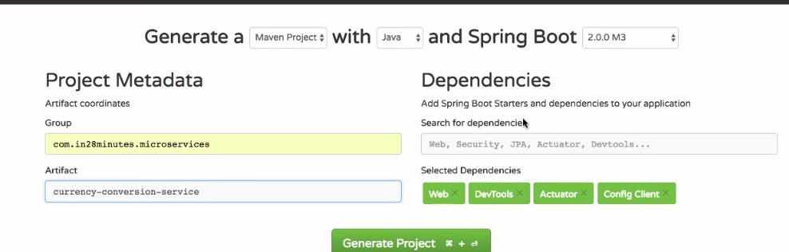

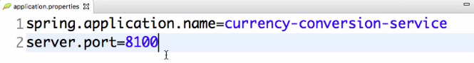

Create a service that will talk to currency exchange service and get conversion multiple.

Currency conversion bean:

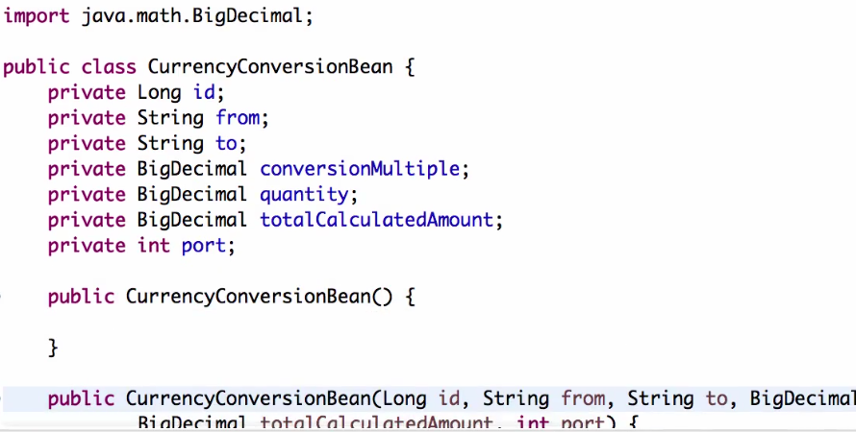

**Invoke using REST Template:** uses hardcoded url of REST service.

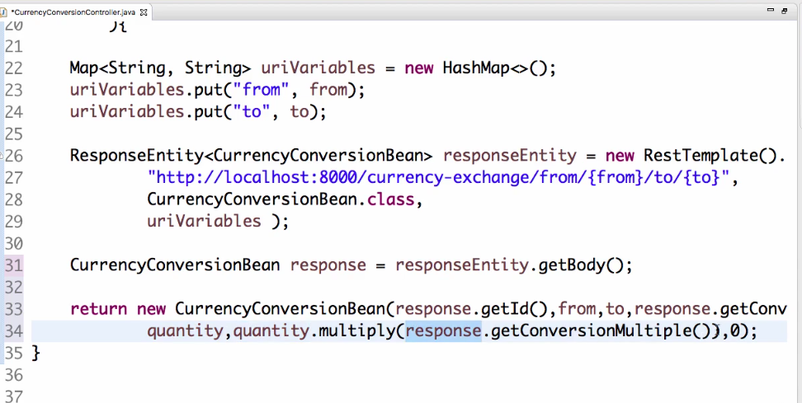

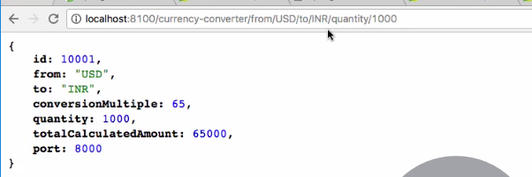

**Feign Client: (Netflix Component)**

**Feign is REST service client, it helps to call RESTful Web services easily.**

* Before we need to write a lot of manual code for calling Rest services. In Micro services environment we need to call many Rest services, so it will be difficult to write all the code manually.
* Feign helps to solve this, also feign has integration with Ribbon.

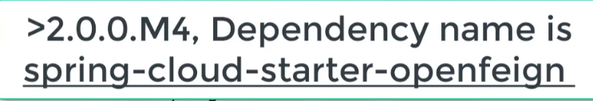

* Then we need to enable Feign using **@EnableFeignClients**.
* we need to create feign proxy.

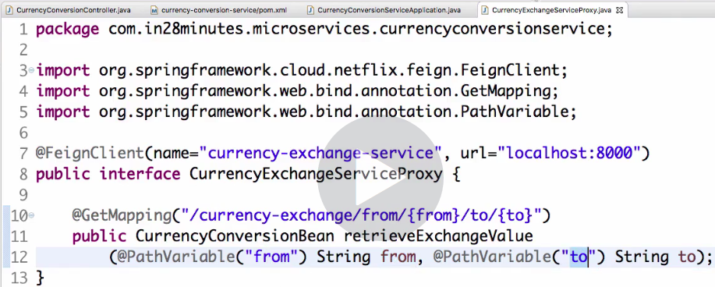

* Now we can use this proxy for calling service in Controller class.

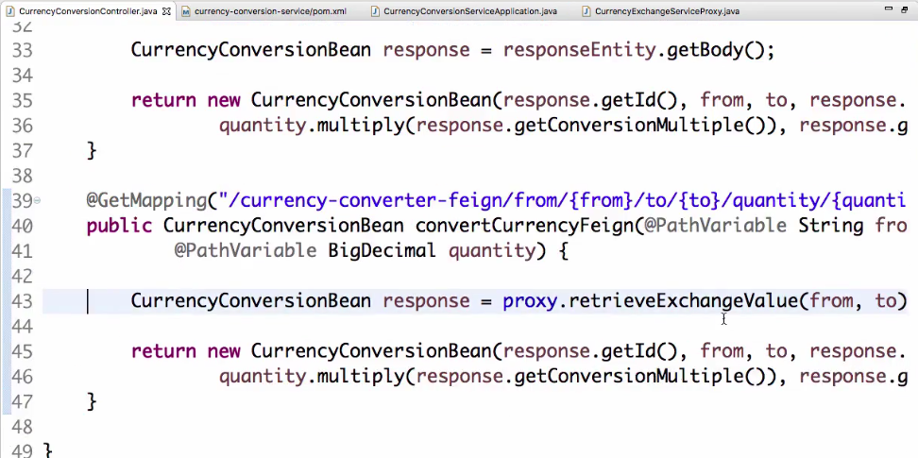

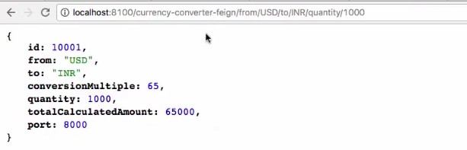

* If there are Currency exchange service is providing 15 services, all the calls will be in single proxy. Application logic no need to Know all these.

**Ribbon: Client-side load balancing**

* Here currency exchange service has 3 instances, but by using feign client we are hard coding the URI of service.
* Ribbon helps to distribute load between all instances of services by use of feign client.

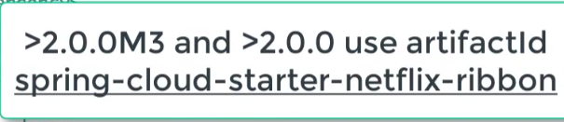

* Need to enable Ribbon on the Proxy using **@RibbonClient** and remove the URL.

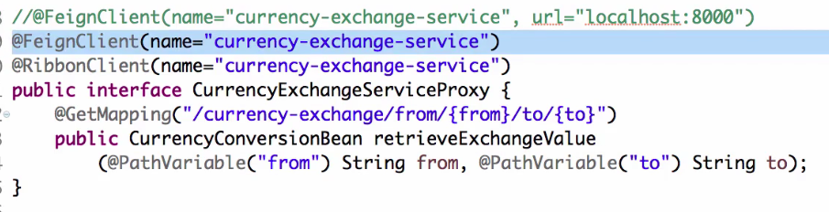

* We need give list of servers for Ribbon from Application.Properties.

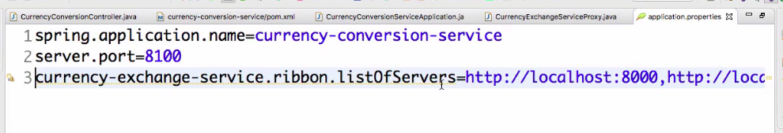

* By this load will be distributed between the instances of the service. One after one

**Eureka Naming Server:**

* If we need to add up one more instance of service, then we need change the configuration file of the consumer service. It is not possible every time for dynamic environments. New instances coming up going down and ports might be changing. So, we need Naming server.

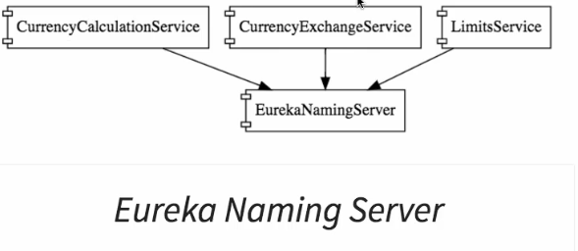

* All the instances of all Micro services will it self-register with naming server when instance come up running, this is called **Service registration.**
* **CCS** will talk to Naming server and get the information about what all instances (location) of CES are running. This is called **Service Discovery.**
* During Start Up of every micro service instance they will do a service registry, when ever a micro service need details of other service it would do a service discovery and get the details.
* **Setting Up Naming server**:

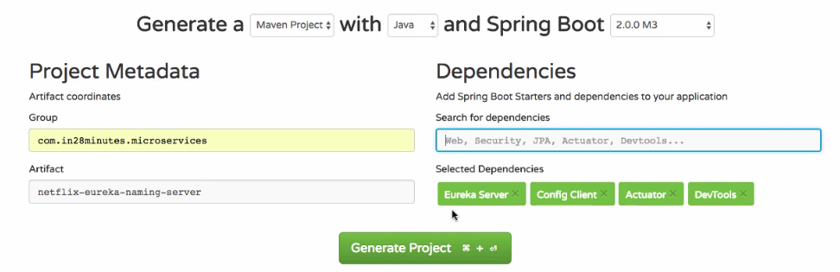

* To Enable Eureka Server need to add **@EnableEurekaServer**

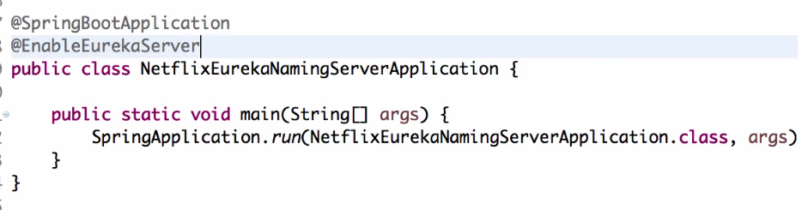

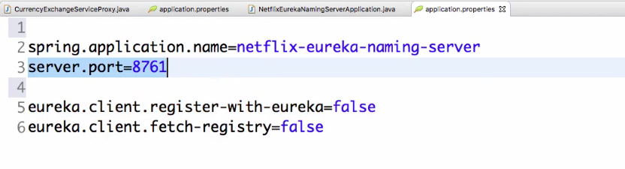

**UI for Eureka**

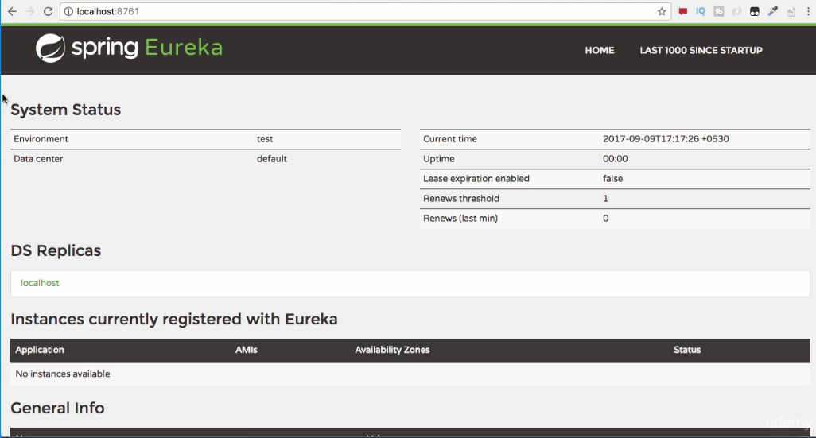

* Make services to register in Eureka server.

**Need to add dependency to Micro service for self-registration.**

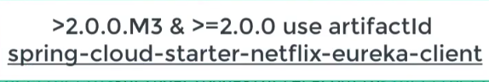

* Add **@EnableDiscoveryClient** to services.

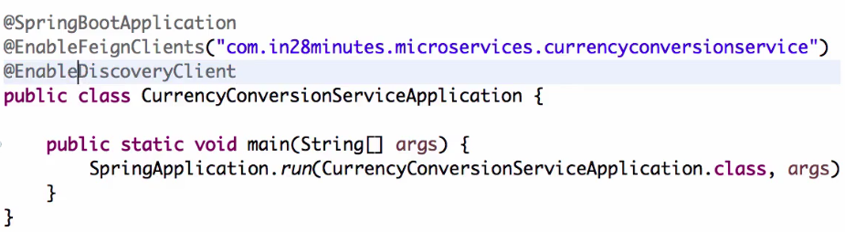

* Now need to configure URL for Eureka in Application properties.

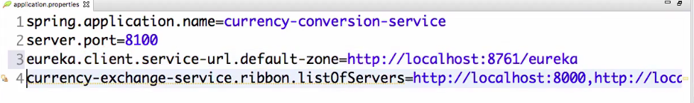

* By this CCS will register automatically to Eureka Server at the start up.
* Similarly connect all other services.

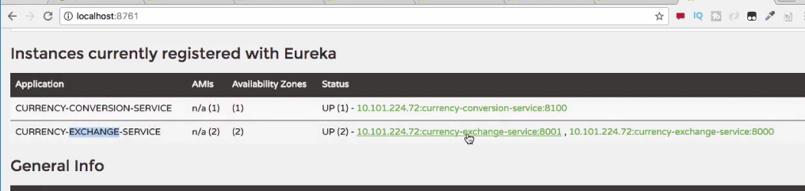

* **Now enable Ribbon to talk to Eureka Naming server and get the instances locations instead of hardcoding in properties file.**

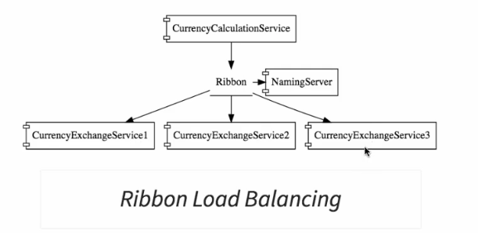

* As the application already configured with Eureka it will automatically talk to Naming server. No changes in the code
* **Ribbon will take care about the instances coming up and going down.**

**API Gateways:**

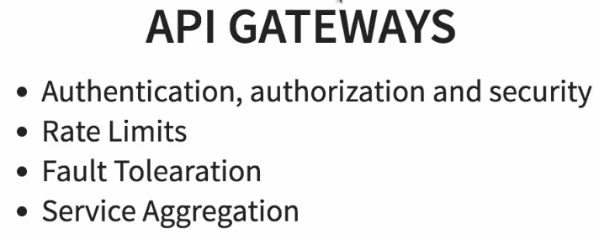

**Netflix Zuul API gateways:**

1. Set the component
2. Decide what things Zuul API should do when it intercepts a request.
3. Make sure right requests go through this Zuul API.

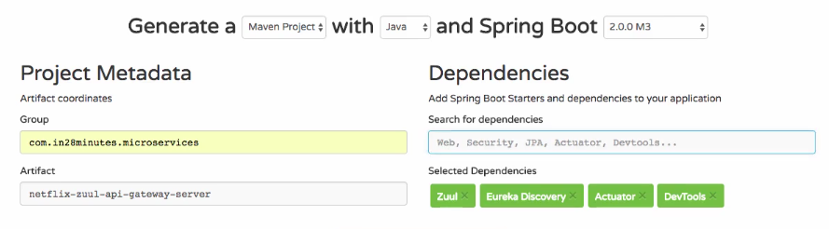

* Now add **@EnableZuulProxy** and **@EnableDiscoveryClient** to spring boot configuration file.

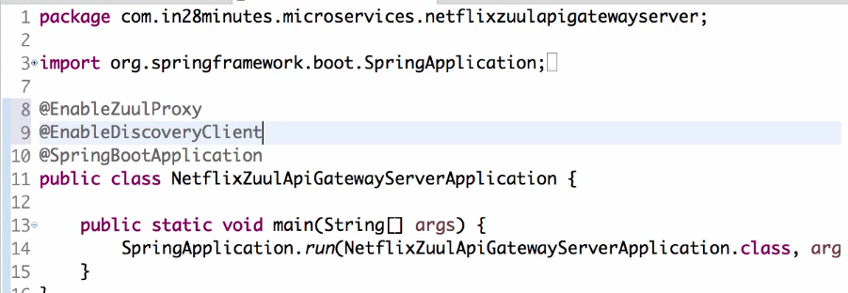

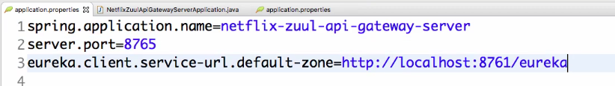

Zuul Logging Filter:

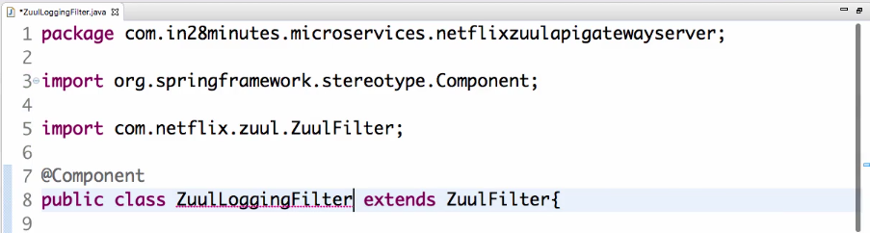

Need to implement 4 unimplemented methods.

filterOrder(): can set priority order between different types of filter like logging, security.

shouldFilter(): can decide should need to execute or not.

filterType(): should filter needs to be executed before the request or after the request or only for error requests.

Run(): need to have business logic what to do with the request.

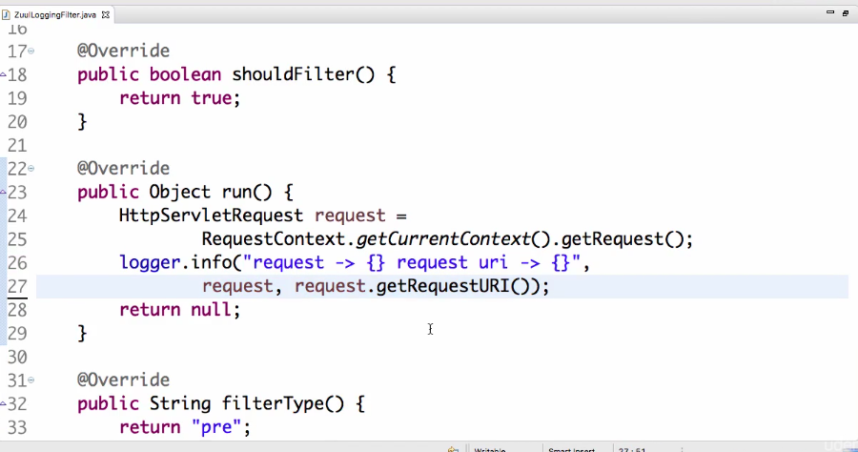

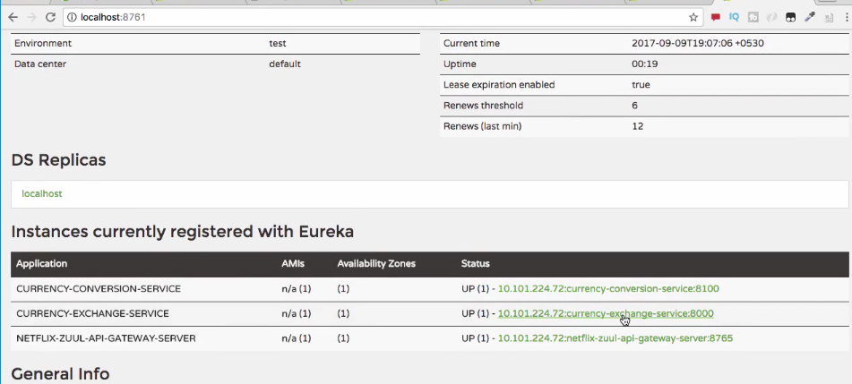

Setting CES through Zuul API gateway

* In order for request go through API gateway we need to set the URL as

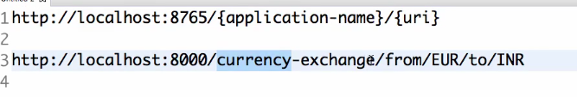

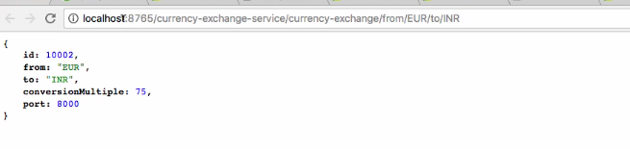

Sending request through API gateway just by changing the URI as above. By the request will be processed through filter.

**Setting Zuul API gateway between Micro service invocations:**

* Just need to remove the direct connection between micro services and add Zuul server for feign client.

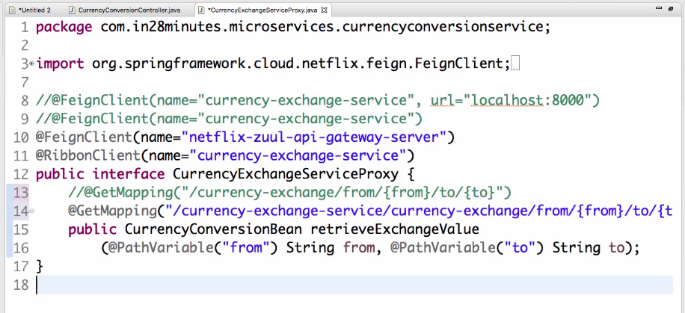

* we can implement Zuul filter for every request going to micro services just following the URL pattern.

**Distributed Tracing:**

* In order to have a centralized way of tracking the request going through different services, we use distributed tracing.
* We can use **Spring Cloud Sleuth with Zipkin.**

**Spring Cloud SLEUTH:**

* It will assign a unique ID to a request so that one can trace it across the components.

**Zipkin** is the distributed tracing system where we do is put all the logs from all services in to RabbitMQ and send it out to the Zipkin server. By this we can look what happened to a specific request.

**Implement Spring Cloud Sleuth:**

2 steps to implement this.

1. Add dependency in pom.xml

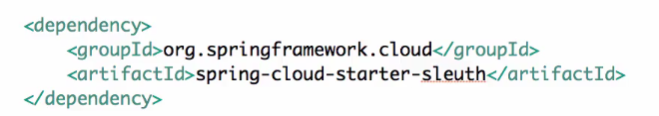

1. Need to tell what all requests need to traced using **Sampler.**

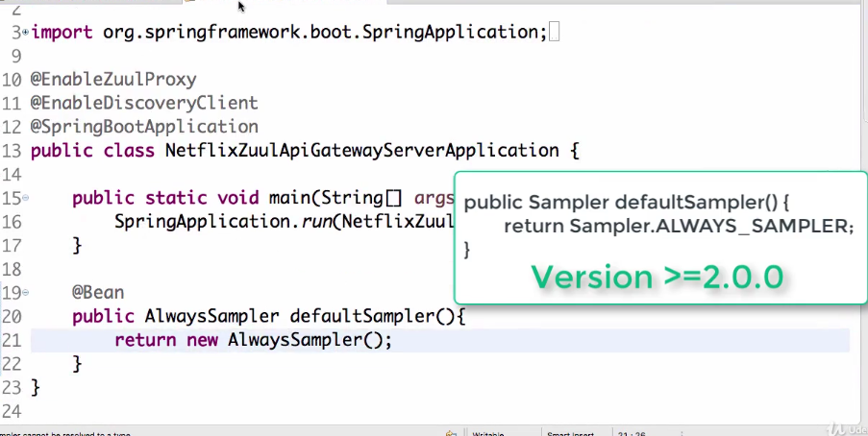

* Implement similar steps in both CES, CCS and Gateway server. Now spring cloud sleuth will add an ID to request going through components.
* As these logs are in different components, we need a centralized place for all these logs and can be able to see in a centralized dashboard. This is where Zipkin helps us.

**Implement Distributed Tracing with Zipkin:**

* we need to bring all logs from different components to a centralized location. So that we can search through ID at single location.
* **Solutions like Elastic search log stash and Kibana, we can consolidate all logs in single place and trace it.**
* Here we use Zipkin Distributed tracing server to consolidate all the logs and see what happens across all the micro services by using UI provided by Zipkin.

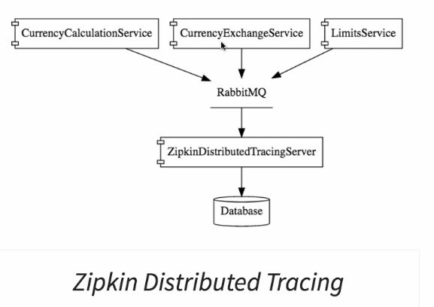

**RabbitMQ:** acts as middleware

* All the micro services will put the messages on queue and Zipkin server would be listening on it and pulls out the log messages from MQ.
* Typically, these Zipkin servers are connected to database, where message from MQ will be pulled to database.

Install RabbitMQ: for installing RabbitMQ we need Erlang to be installed.

It will be running as a background service. Using command launch RabbitMQ.

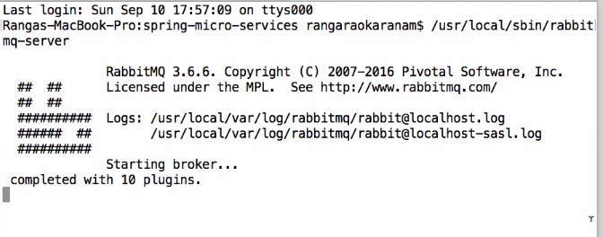

Connect Zipkin distributed tracing server to a database and also make it listen on MQ.

Zipkin dependency is removed from Spring Boot dependencies, so we need to manually download and install the server.

Launch Zipkin Server:

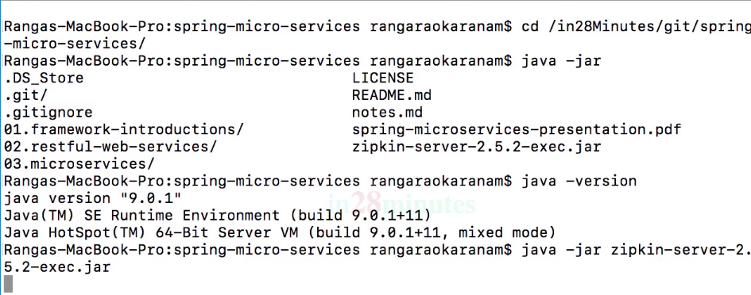

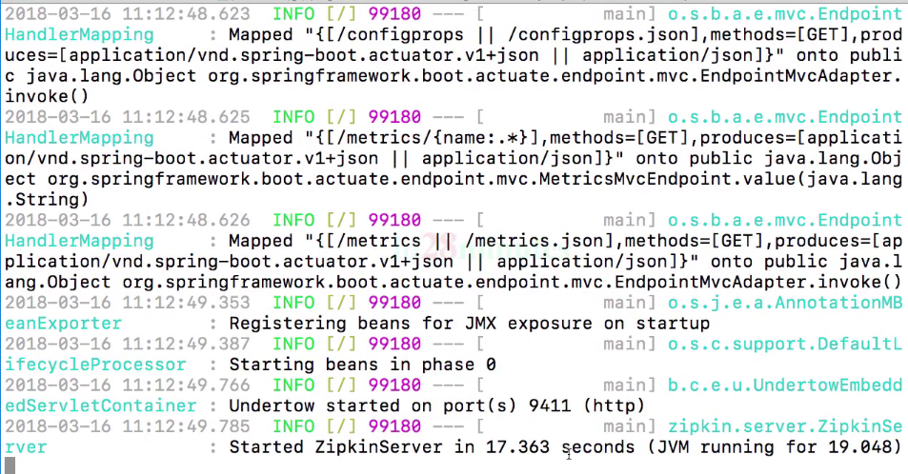

* Now you can check the Zipkin Dashboard.

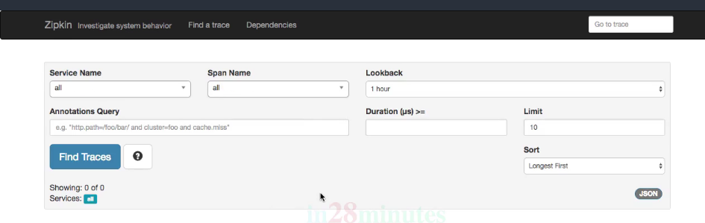

In order to make Zipkin Server to listen to RabbitMQ we need give following command of amqp.

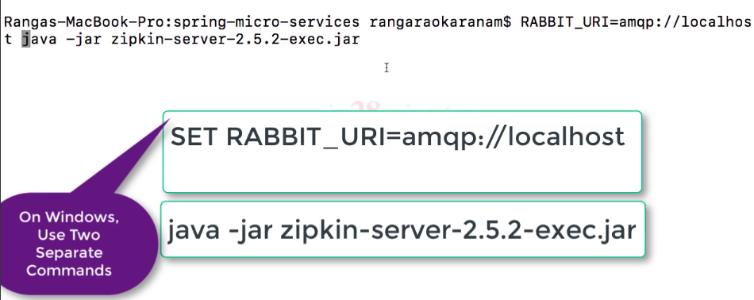

Here Zipkin server is made to listen on RabbitMQ, now we should connect micro services to MQ to enqueue messages.

For this need to add dependency in pom.xml file.

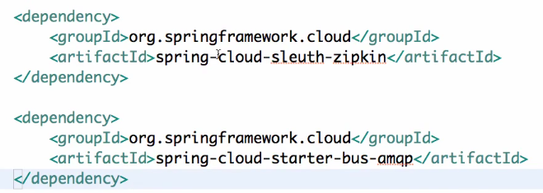

By adding Spring Cloud Sleuth Zipkin dependency it will log the messages in the style that Zipkin will understand.

By adding Spring Cloud Starter bus amqp dependency we are connecting service to RabbitMQ.

Just this is enough no need to change any code.

* From Zipkin Dashboard we can track all the services.

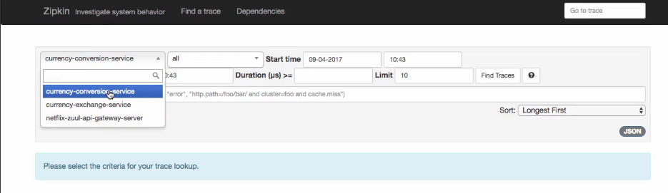

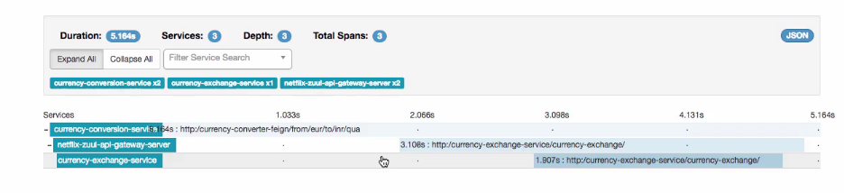

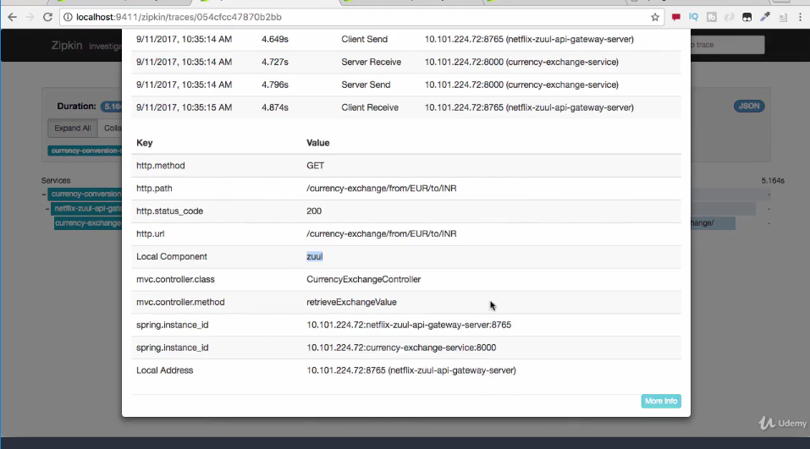

**Spring Cloud Bus:**

* Even After committing the changes of configurations in git repository, we don’t see it reflected in micro services.
* for this we need to send the applicationRefresh post request to the service.

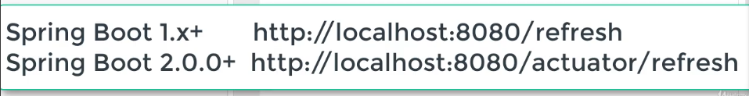

* **we need to have actuators for this.**
* Turn off security for the actuators.

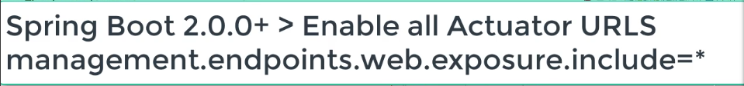

**Now we can send the post request to port to refresh and pull up changes.**

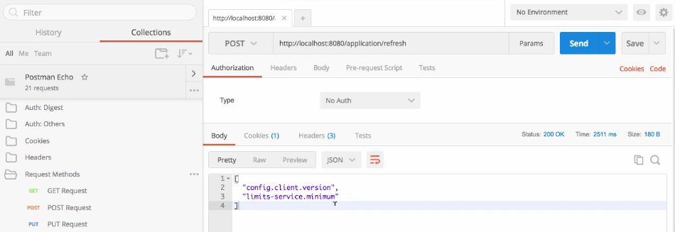

What if there are 100 instances, we need to invoke 100 URL’s to pick up changes which is a maintenance headache.

**By using Spring cloud Bus, if we hit one URL for refresh it will internally hit all other instances of a micro service URL’s and pickup changes from git repo.**

**Implementing Spring Cloud Bus:**

There are multiple options present for Spring Cloud Bus like Kafka, RabbitMQ and soon.

We use RabbitMQ amqp protocol for this. We need to add dependency in both Spring cloud Config server and micro service.

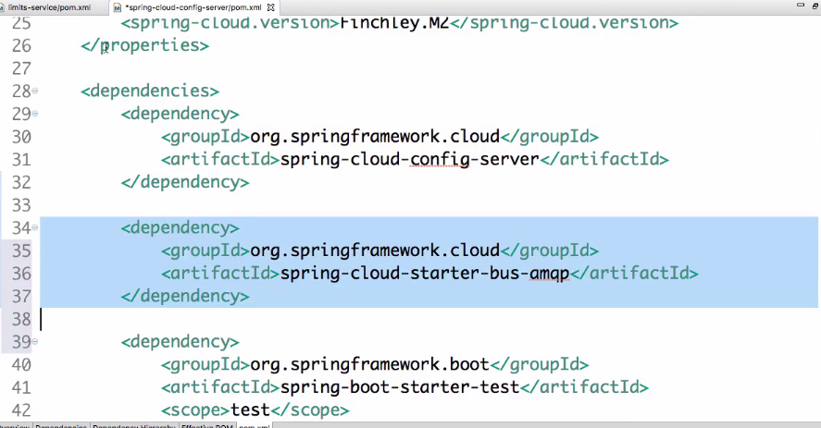

Below will refresh the configuration for all the instances of microservices.

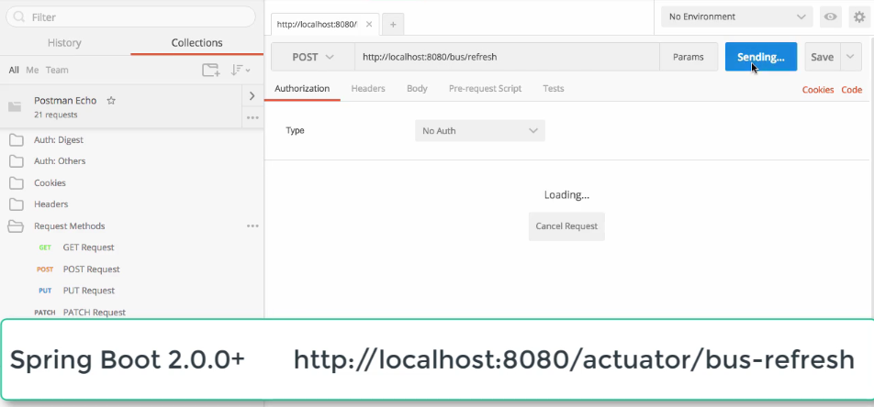

At the startup of instances all of them will register with spring cloud bus. When there is any change in the configuration and refresh is done. Then that particular micro service instance will send event to the bus and spring cloud bus will propagate that event to all the micro services instances that are registered.

**Hystrix:** helps to build Fault tolerance micro services.

* If one service is down it pull down all the services that are chained with that service.
* Micro service should provide the default graceful behavior if the producer service is not responding.

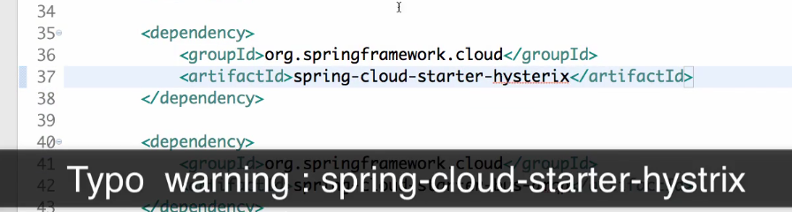

* Then we need to add **@EnableHystric** annotation.
* We can give the fallback method using **@HystrixCommand.** We can give the default configuration in fallback method.

